CO-1 AT-3
QUESTION -1
CODE:
# Load Library
library(ggplot2)
# Dataset
retail <- data.frame(
Branch=c("B1","B2","B3","B4","B5","B6","B7","B8","B9","B10",
"B11","B12","B13","B14","B15","B16","B17","B18","B19","B20"),
Region=c("North","South","East","West","North","South","East","West",
"North","South","East","West","North","South","East","West",
"North","South","East","West"),
Category=c("Electronics","Furniture","Clothing","Food","Electronics",
"Furniture","Clothing","Food","Electronics","Furniture",
"Clothing","Food","Electronics","Furniture","Clothing",
"Food","Electronics","Furniture","Clothing","Food"),
Sales=c(450000,620000,180000,920000,350000,720000,250000,1080000,
560000,670000,195000,980000,430000,760000,280000,1150000,
510000,690000,220000,1250000),
Profit=c(45000,95000,-12000,185000,25000,120000,18000,225000,
72000,98000,-8000,205000,51000,132000,24000,250000,
69000,115000,15000,285000),
Customers=c(1200,2500,980,4200,1800,3000,1250,5200,
2100,3300,1100,4700,1750,3600,1450,5600,
2200,3900,1600,6100)
)
# Retail Dashboard Visualization
ggplot(retail,
aes(x = Sales,
y = Profit,
size = Customers,
color = Region,
shape = Category)) +
geom_point(alpha = 0.9) +
geom_text(aes(label = Branch),
vjust = -1,
size = 3.5,
color = "black") +
scale_size(range = c(4, 14)) +
scale_color_manual(values = c(
"North" = "#1E88E5",
"South" = "#E91E63",
"East" = "#43A047",
"West" = "#FB8C00"
)) +
scale_shape_manual(values = c(
"Electronics" = 16,
"Furniture" = 17,
"Clothing" = 15,
"Food" = 18
)) +
scale_x_log10() +
labs(
title = "Retail Sales Performance Dashboard",
subtitle = "Sales vs Profit with Customers, Region and Category",
x = "Sales (₹) - Log Scale",
y = "Profit (₹)",
color = "Region",
shape = "Category",
size = "Customers"
)
theme_minimal(base_size = 15) +
theme(
plot.title = element_text(size = 20, face = "bold", color = "darkblue"),
plot.subtitle = element_text(size = 13, color = "darkred"),
axis.title = element_text(face = "bold"),
legend.position = "right",
panel.grid.major = element_line(color = "gray85"),
panel.grid.minor = element_blank(),
plot.background = element_rect(fill = "#F8F9FA", color = NA)
EXPLANATION:
1. library(ggplot2)
- Loads the ggplot2 package.
- Used to create attractive and professional visualizations.

2. retail <- data.frame(...)
- Creates a data frame named retail.
- Stores Branch, Region, Category, Sales, Profit, and Customers data.

3. ggplot(retail, aes(...))
- Initializes the graph.
- Maps variables to visual aesthetics.
- Sales → X-axis.
- Profit → Y-axis.
- Customers → Bubble size.
- Region → Bubble color.
- Category → Bubble shape.

4. geom_point(alpha=0.9)
- Draws the bubbles (points).
- alpha=0.9 adds slight transparency.
- Makes overlapping bubbles easier to see.

5. geom_text(aes(label=Branch))
- Displays branch names (B1, B2, B3, etc.).
- Places labels above each bubble for easy identification.

6. scale_size(range=c(4,14))
- Controls the minimum and maximum bubble size.
- Larger bubbles represent more customers.

7. scale_color_manual()
- Assigns different colors to each region.
- Helps distinguish North, South, East, and West easily.

8. scale_shape_manual()
- Assigns different shapes for each product category.
- Makes Electronics, Furniture, Clothing, and Food easy to identify.

9. scale_x_log10()
- Applies a logarithmic scale to the Sales axis.
- Compresses large sales values.
- Improves comparison between small and large branches.

10. labs()
- Adds a graph title.
- Adds a subtitle.
- Labels the X-axis and Y-axis.
- Displays legend titles.

11. theme_minimal()
- Applies a clean and professional theme.
- Removes unnecessary background elements.
- Improves graph readability.

Aesthetic Mapping
- X-axis → Sales
- Y-axis → Profit
- Bubble Size → Customers
- Bubble Color → Region
- Bubble Shape → Category
- Branch Labels → Branch Names

Why Logarithmic Scale?
- Sales values vary widely.
- Compresses large values.
- Makes all branches visible.
- Improves comparison.

Advantages of the Visualization
- Displays five variables in a single chart.
- Easy to compare sales and profit.
- Bubble size shows customer count.
- Colors identify regions.
- Shapes distinguish product categories.
- Professional and easy to interpret.

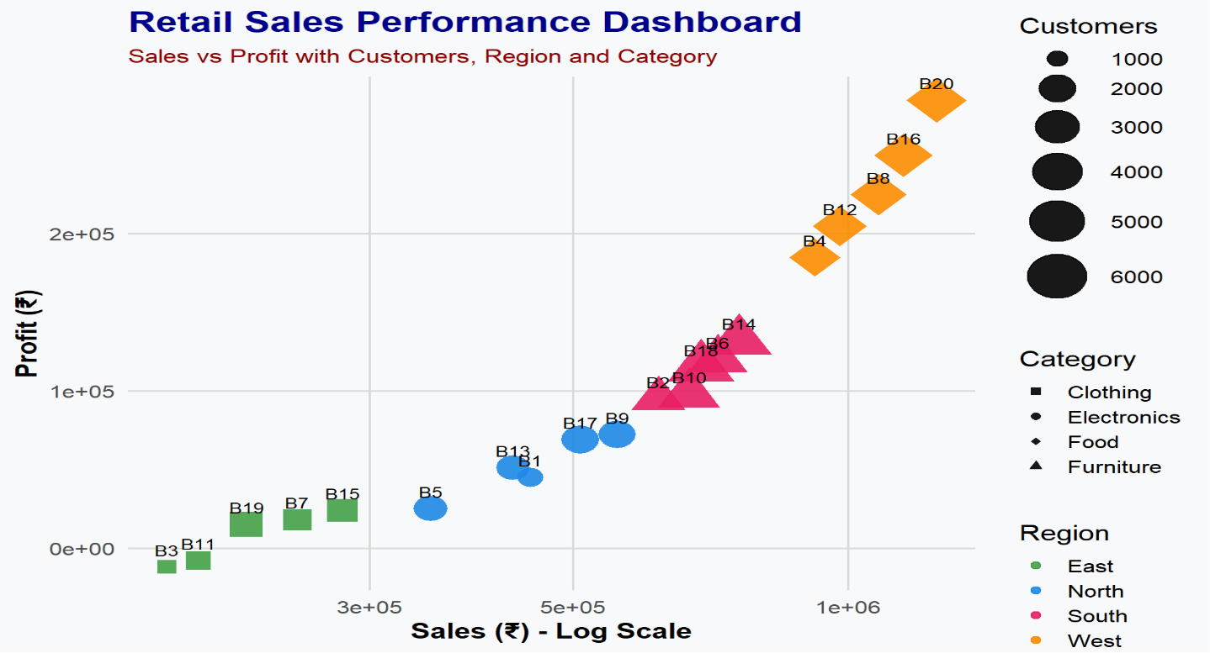
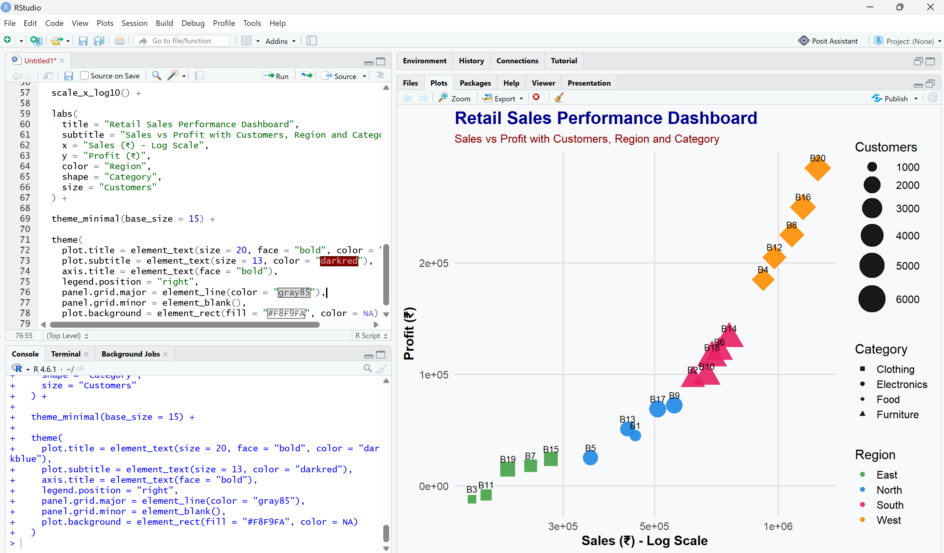

QUESTION 2
CODE:
# Load Library
library(ggplot2)
# Dataset
energy <- data.frame(
Month = month.abb,
Coal = c(620,580,590,605,640,670,690,720,700,680,650,630),
Gas = c(310,295,305,320,340,355,360,370,365,350,335,320),
Solar = c(45,60,90,130,180,230,250,245,210,160,90,50),
Wind = c(80,95,120,150,170,185,195,190,175,150,110,90),
Hydro = c(140,150,160,170,180,195,205,210,200,185,165,150)
)
# Convert data into long format
energy_long <- data.frame(
Month = rep(energy$Month, 5),
Source = rep(c("Coal","Gas","Solar","Wind","Hydro"),
each = nrow(energy)),
Generation = c(
energy$Coal,
energy$Gas,
energy$Solar,
energy$Wind,
energy$Hydro
)
)
#############################################
# Q1 Cartesian Coordinate Visualization
#############################################
ggplot(energy_long,
aes(x = Month,
y = Generation,
group = Source,
color = Source)) +
geom_line(size = 1.5) +
geom_point(size = 3) +
scale_color_manual(values = c(
"Coal" = "#4E342E",
"Gas" = "#1E88E5",
"Solar" = "#FDD835",
"Wind" = "#00ACC1",
"Hydro" = "#43A047"
)) +
labs(
title = "Monthly Electricity Generation",
subtitle = "Cartesian Coordinate System",
x = "Month",
y = "Generation (MW)",
color = "Energy Source"
) +
theme_minimal(base_size = 15) +
theme(
plot.title = element_text(face = "bold",
size = 20,
color = "darkblue"),
plot.subtitle = element_text(size = 13),
axis.title = element_text(face = "bold"),
legend.position = "right"
)
#############################################
# Q2 Polar Coordinate Visualization
#############################################
ggplot(energy_long,
aes(x = Month,
y = Generation,
fill = Source)) +
geom_bar(stat = "identity",
position = "stack",
color = "white") +
coord_polar() +
scale_fill_manual(values = c(
"Coal" = "#4E342E",
"Gas" = "#1E88E5",
"Solar" = "#FDD835",
"Wind" = "#00ACC1",
"Hydro" = "#43A047"
)) +
labs(
title = "Electricity Generation by Energy Source",
subtitle = "Polar Coordinate System",
fill = "Energy Source"
) +
theme_minimal(base_size = 15) +
theme(
plot.title = element_text(face = "bold",
size = 20,
color = "darkred"),
plot.subtitle = element_text(size = 13),
axis.title = element_blank(),
axis.text = element_blank(),
axis.ticks = element_blank()
)
#############################################
# Q3 Comparison
#############################################
cat("Comparison:\n")
cat("- Cartesian chart provides accurate comparison of monthly electricity generation.\n")
cat("- Polar chart provides an attractive circular representation but makes exact comparison more difficult.\n\n")
#############################################
# Q4 Appropriate Coordinate System
#############################################

cat("Most Appropriate Coordinate System:\n")
cat("Cartesian Coordinate System\n\n")
#############################################
# Q5 Justification
#############################################
cat("Justification:\n")
cat("Cartesian coordinates allow easy comparison of energy generation across months and energy sources using a common scale.\n")
cat("Polar coordinates are visually appealing but are better suited for cyclical or directional data rather than precise quantitative comparison.\n")
EXPLANATION:
1. library(ggplot2)
- Loads the ggplot2 package.
- Used to create attractive and professional visualizations.

2. energy <- data.frame(...)
- Creates a data frame named energy.
- Stores monthly electricity generation data for:
  - Coal
  - Gas
  - Solar
  - Wind
  - Hydro

3. energy_long <- data.frame(...)
- Converts the dataset into long format.
- Makes it easier to plot multiple energy sources using ggplot2.
- Each row contains:
  - Month
  - Energy Source
  - Generation Value

Cartesian Coordinate Visualization
4. ggplot(energy_long, aes(...))
- Initializes the graph.
- Maps:
  - Month → X-axis
  - Generation → Y-axis
  - Energy Source → Color

5. geom_line(size=1.5)
- Draws a line for each energy source.
- Shows the monthly generation trend.

6. geom_point(size=3)
- Adds points to each month's value.
- Makes individual observations easy to identify.

7. scale_color_manual()
- Assigns different colors to each energy source.
Energy Source | Color
Coal | Brown
Gas | Blue
Solar | Yellow
Wind | Cyan
Hydro | Green

8. labs()
- Adds graph title.
- Adds subtitle.
- Labels X-axis and Y-axis.
- Displays legend title.

9. theme_minimal()
- Applies a clean and professional appearance.
- Improves readability.

Polar Coordinate Visualization
10. geom_bar(stat="identity")
- Creates stacked bars using the generation values.
- Each bar represents a month.

11. coord_polar()
- Converts the bar chart into a circular (polar) chart.
- Displays data in a radial format.

12. scale_fill_manual()
- Assigns different colors to each energy source.
- Improves distinction between categories.

13. theme_minimal()
- Gives the polar chart a clean appearance.
- Removes unnecessary visual clutter.

Comparison of Both Visualizations
Cartesian Coordinate System
- Easy to compare monthly electricity generation.
- Clearly shows increasing and decreasing trends.
- Provides accurate quantitative comparison.

Polar Coordinate System
- Attractive circular representation.
- Suitable for cyclical or seasonal data.
- Exact value comparison is more difficult.

Which Coordinate System is More Appropriate?
- Cartesian Coordinate System

Justification
- Provides accurate comparison using a common scale.
- Clearly shows trends across months.
- Easier to interpret numerical values.
- Better for analytical purposes.

Advantages of the Visualization
- Displays multiple energy sources together.
- Different colors distinguish each source.
- Line chart clearly shows trends over time.
- Polar chart provides an attractive circular view.
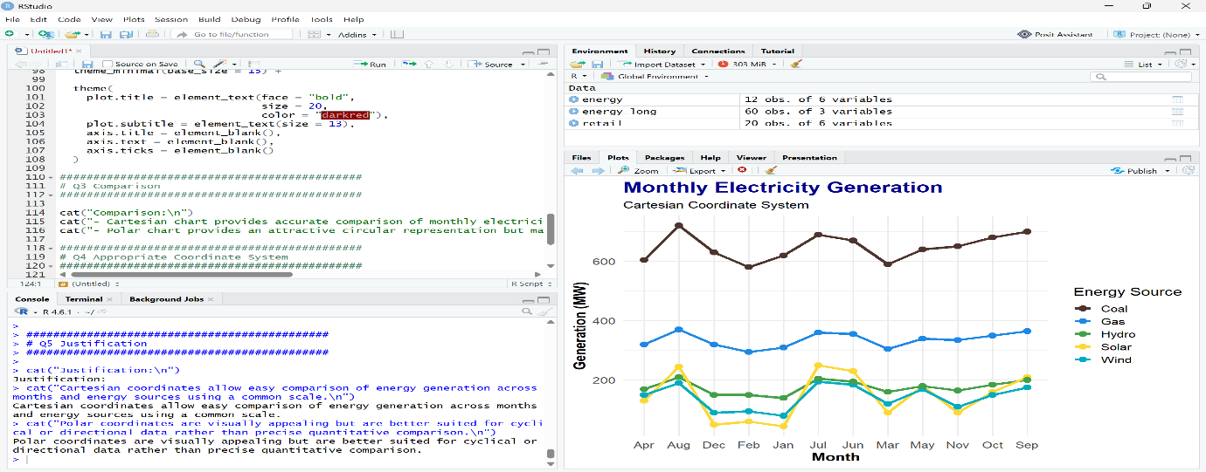
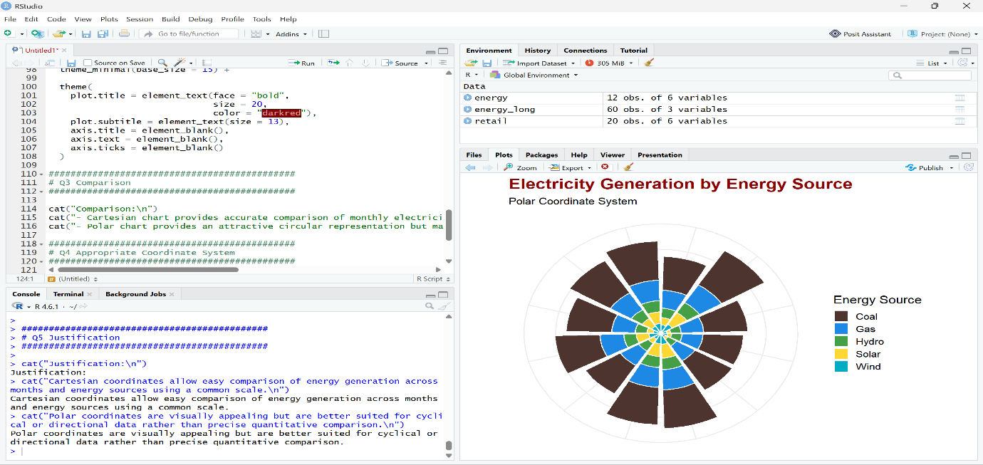
- Both visualizations complement each other.

QUESTION 3
CODE:
# Load Library
library(ggplot2)
# Dataset
climate <- data.frame(
City=c("Delhi","Mumbai","Chennai","Kolkata","Hyderabad",
"Bangalore","Pune","Ahmedabad","Jaipur","Lucknow",
"Bhopal","Patna","Goa","Kochi","Nagpur","Indore",
"Surat","Visakhapatnam","Coimbatore","Mysuru"),
Temperature=c(44,35,38,40,39,31,33,43,45,39,
38,40,32,30,41,37,36,34,29,28),
Humidity=c(22,84,78,72,48,66,58,26,18,42,
36,45,89,91,30,34,76,82,68,64),
Rainfall=c(6,280,220,190,85,120,95,2,1,35,
48,72,360,410,12,20,180,240,130,145),
AQI=c(365,110,125,180,160,72,84,290,320,240,
175,220,58,52,270,190,145,98,60,55)
)
##############################################################
# Climate Visualization
##############################################################
ggplot(climate,
aes(x=Temperature,
y=AQI,
size=Rainfall,
color=Humidity))+
geom_point(alpha=0.85)+
geom_text(aes(label=City),
vjust=-1,
size=3.5,
color="black")+
scale_size(range=c(4,15))+
scale_color_gradient(
low="#00B4D8",
high="#D00000"
)+
labs(
title="Climate Monitoring Dashboard",
subtitle="Temperature, AQI, Rainfall and Humidity",
x="Temperature (°C)",
y="Air Quality Index (AQI)",
size="Rainfall (mm)",
color="Humidity (%)"
)+
theme_minimal(base_size=15)+
theme(
plot.title=element_text(face="bold",
size=20,
color="darkblue"),
plot.subtitle=element_text(size=13,
color="darkred"),
axis.title=element_text(face="bold"),
legend.position="right",
panel.grid.major=element_line(color="grey80"),
panel.grid.minor=element_blank()
)
##############################################################
# Question 3
##############################################################
cat("Interpretation:\n")
cat("- Higher temperatures generally correspond to higher AQI in some cities.\n")
cat("- Larger bubbles indicate higher rainfall.\n")
cat("- Darker colors represent higher humidity.\n\n")
##############################################################
# Question 4
##############################################################
cat("Continuous Variables:\n")
cat("Temperature, Humidity, Rainfall, AQI\n\n")
cat("Categorical Variable:\n")
cat("City\n\n")
##############################################################
# Question 5
##############################################################
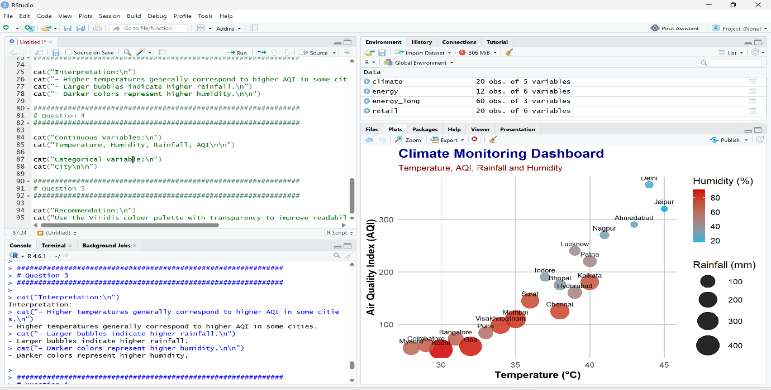
cat("Recommendation:\n")
EXPLANATION:
1. library(ggplot2)
- Loads the ggplot2 package.
- Used to create attractive and professional visualizations.

2. climate <- data.frame(...)
- Creates a data frame named climate.
- Stores data for:
  - City
  - Temperature
  - AQI (Air Quality Index)
  - Rainfall
  - Humidity

3. ggplot(climate, aes(...))
- Initializes the graph.
- Maps variables to visual aesthetics.
- Temperature → X-axis.
- AQI → Y-axis.
- Rainfall → Bubble size.
- Humidity → Bubble color.

4. geom_point(alpha=0.85)
- Draws the bubbles (points).
- alpha=0.85 adds slight transparency.
- Makes overlapping bubbles easier to see.

5. geom_text(aes(label=City))
- Displays city names beside each bubble.
- Makes it easy to identify each city's data.

6. scale_size(range=c(4,14))
- Controls the minimum and maximum bubble size.
- Larger bubbles represent higher rainfall.

7. scale_color_gradient()
- Applies a color gradient based on humidity.
- Lower humidity is shown with lighter colors.
- Higher humidity is shown with darker colors.

8. labs()
- Adds the graph title.
- Adds a subtitle.
- Labels the X-axis and Y-axis.
- Displays legend titles.

9. theme_minimal()
- Applies a clean and professional theme.
- Improves readability by removing unnecessary background elements.

Aesthetic Mapping
- X-axis → Temperature (°C)
- Y-axis → AQI
- Bubble Size → Rainfall (mm)
- Bubble Color → Humidity (%)
- Labels → City Names

Interpretation
- Higher temperatures can be compared with AQI levels.
- Larger bubbles indicate cities with more rainfall.
- Darker colors represent higher humidity.
- City labels help identify individual observations.

Variables Used
Continuous Variables
- Temperature
- AQI
- Rainfall
- Humidity
Categorical Variable
- City

Advantages of the Visualization
- Displays multiple climate variables in a single chart.
- Bubble size highlights rainfall differences.
- Color gradient shows humidity levels clearly.
- City labels improve identification.
- Makes comparison between cities easy.

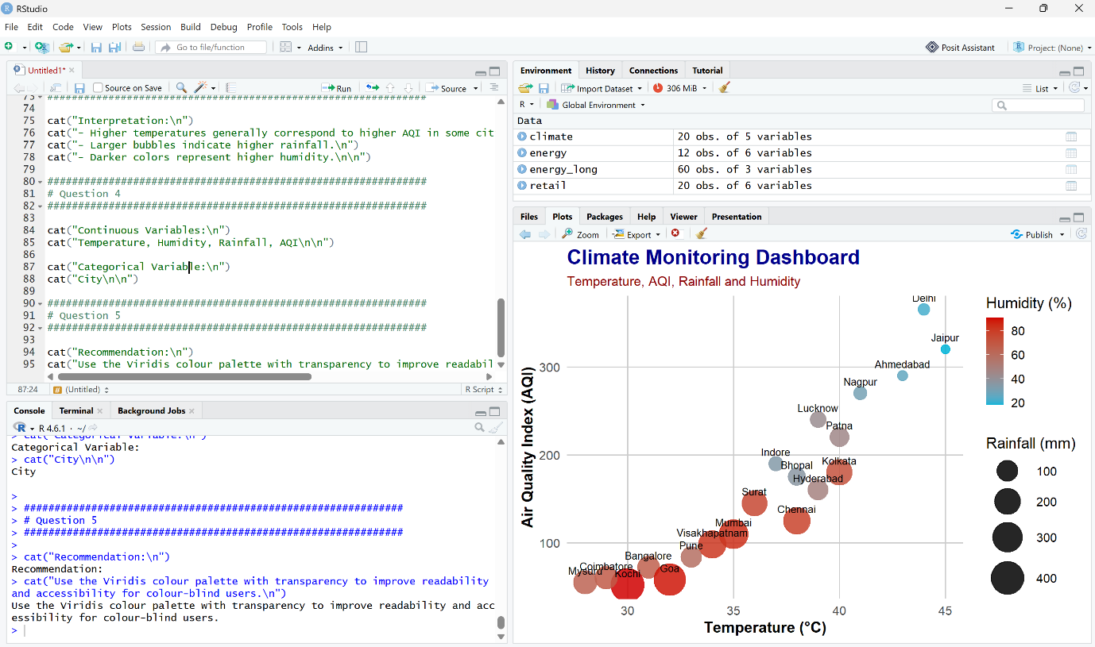
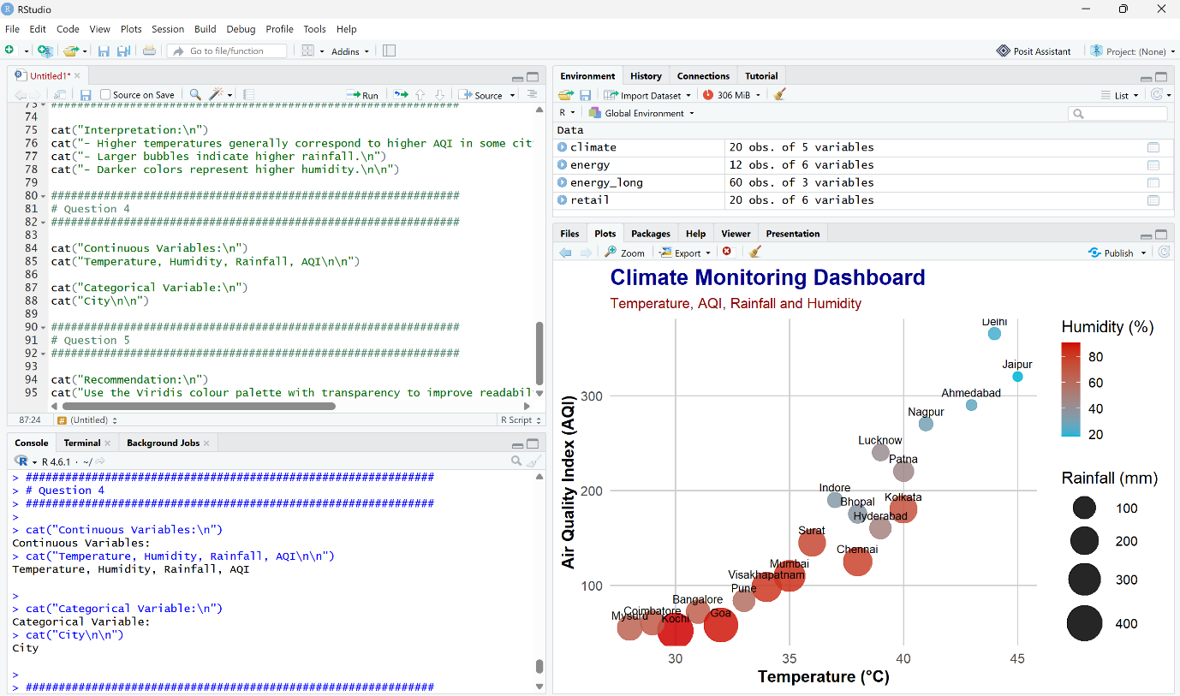
cat("Use the Viridis colour palette with transparency to improve readability and accessibility for colour-blind users.\n")

QUESTION 4
CODE:
# Load Library
library(ggplot2)

# Dataset
software <- data.frame(
Team=paste("T",1:20,sep=""),
LinesOfCode=c(12000,18000,25000,35000,48000,
62000,81000,96000,120000,150000,
185000,240000,310000,390000,480000,
620000,810000,1050000,1350000,1800000),

Bugs=c(35,52,60,72,88,
110,125,142,165,188,
205,240,280,320,365,
420,490,560,640,720),

Developers=c(5,7,9,10,12,
14,16,18,20,22,
25,28,30,34,38,
42,46,50,55,60),

Complexity=c(2.1,2.4,2.7,3.0,3.2,
3.5,3.8,4.1,4.5,4.8,
5.1,5.4,5.8,6.2,6.6,
7.1,7.6,8.0,8.5,9.0)
)

######################################################
# Software Analytics Visualization
######################################################

ggplot(software,
aes(x=LinesOfCode,
y=Bugs,
size=Developers,
color=Complexity))+

geom_point(alpha=0.85)+

geom_text(aes(label=Team),
vjust=-1,
size=3.5,
color="black")+

scale_x_log10()+

scale_size(range=c(4,15))+

scale_color_gradient(
low="#00C9A7",
high="#D90429"
)+

labs(
title="Software Development Analytics Dashboard",
subtitle="Logarithmic Scale for Lines of Code",
x="Lines of Code (Log Scale)",
y="Number of Bugs",
size="Developers",
color="Complexity"
)+

theme_minimal(base_size=15)+

theme(
plot.title=element_text(face="bold",
size=20,
color="darkblue"),

plot.subtitle=element_text(size=13,
color="darkred"),

axis.title=element_text(face="bold"),

legend.position="right",

panel.grid.major=element_line(color="grey80"),

panel.grid.minor=element_blank()
)

######################################################
# Question 3
######################################################

cat("Interpretation:\n")
cat("- Projects with higher Lines of Code generally contain more bugs.\n")
cat("- Larger bubbles represent teams with more developers.\n")
cat("- Darker colours indicate higher software complexity.\n\n")

######################################################
# Question 4
######################################################

cat("Why Logarithmic Scale?\n")
cat("- Lines of Code range from 12,000 to 1,800,000.\n")
cat("- Log transformation compresses large values.\n")
cat("- Makes comparison easier.\n")
cat("- Prevents smaller projects from appearing clustered together.\n\n")

######################################################
# Question 5
######################################################

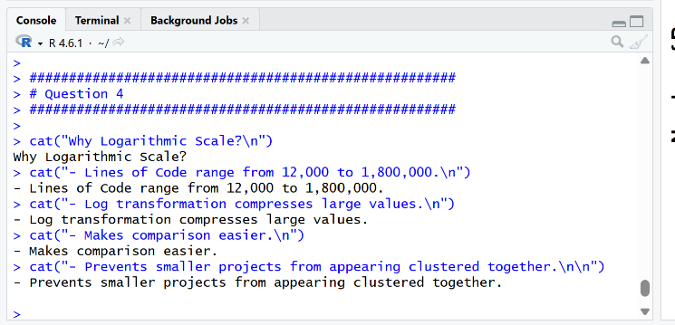
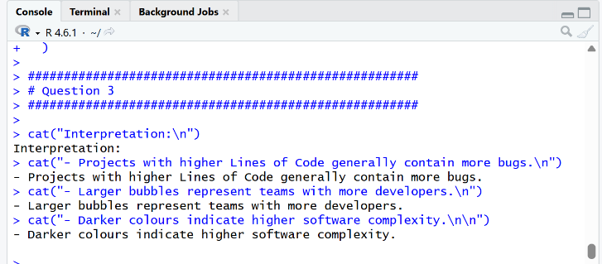
cat("Conclusion:\n")
cat("A logarithmic scale provides better readability and interpretation than a linear scale for highly skewed software project data.\n")
EXPLANATION:
1. library(ggplot2)
- Loads the ggplot2 package.
- Used to create attractive and professional visualizations.

2. software <- data.frame(...)
- Creates a data frame named software.
- Stores details of:
  - Team
  - Lines of Code (LOC)
  - Bugs
  - Developers
  - Complexity

3. ggplot(software, aes(...))
- Initializes the graph.
- Maps variables to visual aesthetics.
- Lines of Code → X-axis.
- Bugs → Y-axis.
- Developers → Bubble size.
- Complexity → Bubble color.

4. geom_point(alpha=0.85)
- Draws the bubbles (points).
- alpha=0.85 adds slight transparency.
- Makes overlapping bubbles easier to distinguish.

5. geom_text(aes(label=Team))
- Displays team names (T1, T2, T3, etc.).
- Places labels above each bubble for easy identification.

6. scale_x_log10()
- Applies a logarithmic scale to the Lines of Code axis.
- Compresses very large LOC values.
- Makes both small and large projects easy to compare.
- Prevents smaller values from appearing crowded together.

7. scale_size(range=c(4,15))
- Controls the minimum and maximum bubble size.
- Larger bubbles represent teams with more developers.

8. scale_color_gradient()
- Applies a color gradient based on software complexity.
- Lower complexity is shown with lighter colors.
- Higher complexity is shown with darker colors.

9. labs()
- Adds the graph title.
- Adds a subtitle.
- Labels the X-axis and Y-axis.
- Displays legend titles.

10. theme_minimal()
- Applies a clean and professional theme.
- Removes unnecessary background elements.
- Improves readability.

Aesthetic Mapping
- X-axis → Lines of Code (Log Scale)
- Y-axis → Number of Bugs
- Bubble Size → Number of Developers
- Bubble Color → Software Complexity
- Labels → Team Names

Interpretation
- Projects with more Lines of Code generally have more Bugs.
- Larger bubbles represent teams with more Developers.
- Darker-colored bubbles indicate higher software complexity.
- Team labels help identify individual projects.

Why Use a Logarithmic Scale?
- Lines of Code values vary from 12,000 to 1,800,000.
- A logarithmic scale compresses large values.
- Improves readability and comparison.
- Makes trends easier to identify.

Advantages of the Visualization
- Displays multiple software metrics in one graph.
- Bubble size highlights team size.
- Color represents software complexity.
- Log scale improves comparison across projects.
- Easy to identify trends between code size and bugs.

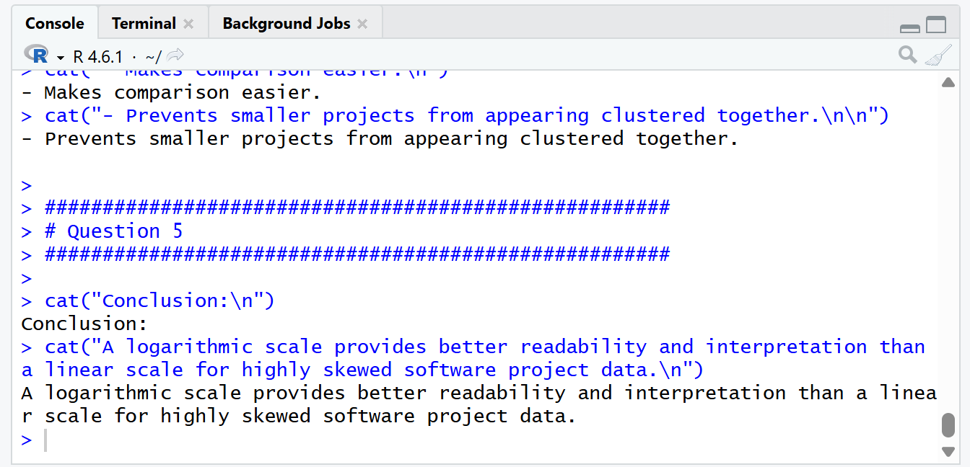

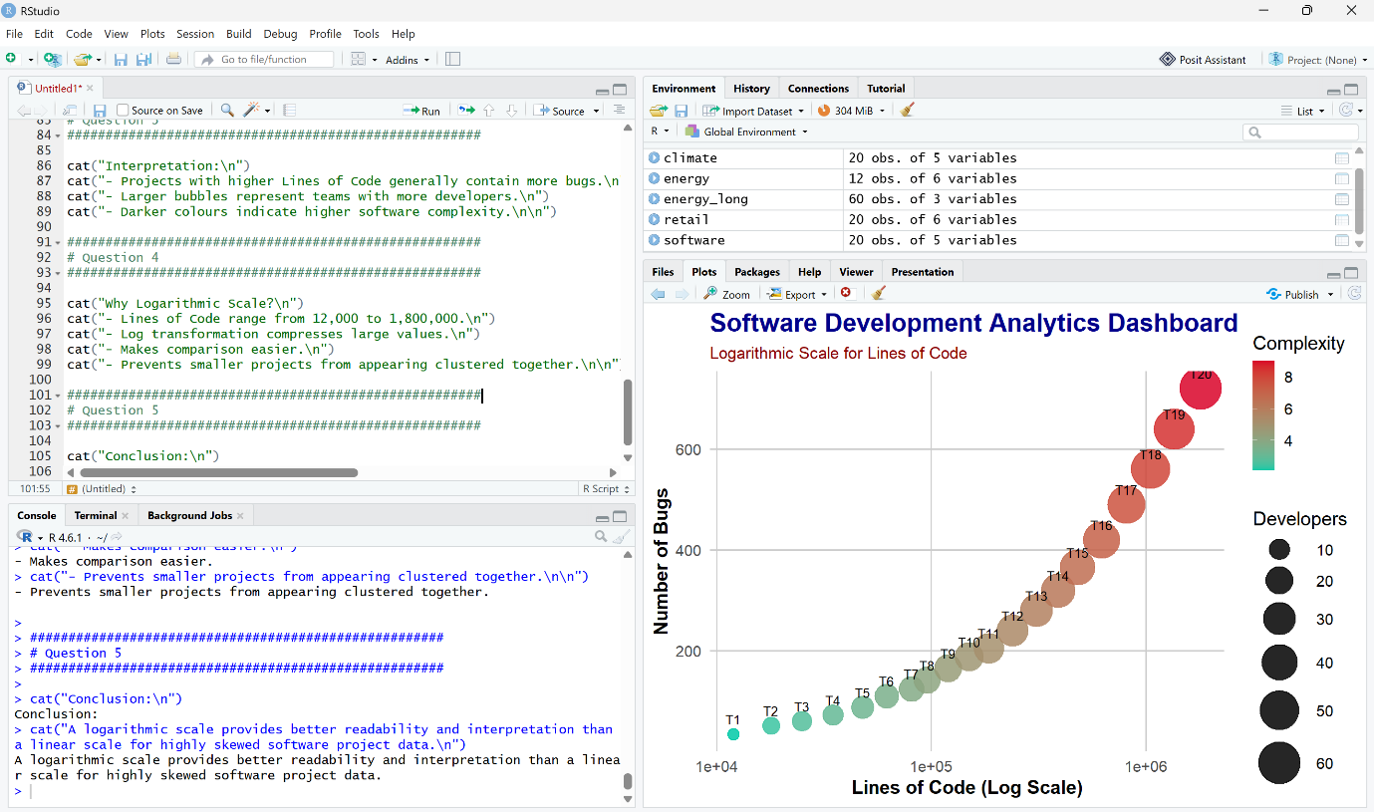

QUESTION 5
CODE:
# Load Library
library(ggplot2)

# Dataset
companies <- data.frame(
Company=paste("C",1:20,sep=""),
Sector=c("IT","Banking","Healthcare","Retail","Energy",
"IT","Banking","Healthcare","Retail","Energy",
"IT","Banking","Healthcare","Retail","Energy",
"IT","Banking","Healthcare","Retail","Energy"),

Revenue=c(420,580,720,850,980,
1150,1320,1480,1650,1820,
2050,2280,2550,2840,3150,
3480,3860,4250,4680,5200),

ProfitMargin=c(8.2,15.6,11.4,9.3,18.5,
20.4,17.8,14.2,10.5,22.1,
24.5,19.8,16.7,13.4,26.2,
28.1,21.5,18.3,15.2,30.4),

Employees=c(1500,3200,2100,4200,2800,
5100,6800,3900,7200,4500,
8100,9500,6200,10300,7200,
11800,13200,8600,14500,16000),

MarketCap=c(8500,12000,9800,7600,14500,
18200,21500,16800,13200,24500,
28500,32500,24800,19200,38200,
42500,46800,35600,29800,52000)
)

###########################################################
# Integrated Visualization
###########################################################

ggplot(companies,
aes(x=Revenue,
y=ProfitMargin,
size=MarketCap,
color=Sector))+

geom_point(alpha=0.85)+

geom_text(aes(label=Company),
vjust=-1,
size=3.8,
color="black")+

scale_size(range=c(5,18))+

scale_color_manual(values=c(
"IT"="#4361EE",
"Banking"="#F72585",
"Healthcare"="#06D6A0",
"Retail"="#F4A261",
"Energy"="#FFBE0B"
))+

labs(
title="Financial Analytics Dashboard",
subtitle="Revenue vs Profit Margin with Market Capitalization",
x="Revenue (₹ Crores)",
y="Profit Margin (%)",
size="Market Capitalization",
color="Industry Sector"
)+

theme_minimal(base_size=15)+

theme(
plot.title=element_text(
face="bold",
size=20,
color="darkblue"),

plot.subtitle=element_text(
size=13,
color="darkred"),

axis.title=element_text(face="bold"),

legend.position="right",

panel.grid.major=element_line(color="grey80"),

panel.grid.minor=element_blank()
)

###########################################################
# Question 2
###########################################################

cat("Aesthetic Mapping:\n")
cat("Revenue -> X-axis\n")
cat("Profit Margin -> Y-axis\n")
cat("Market Cap -> Bubble Size\n")
cat("Industry Sector-> Colour\n")
cat("Company -> Labels\n\n")

###########################################################
# Question 3
###########################################################

cat("Interpretation:\n")
cat("- Companies with higher revenue generally have higher profit margins.\n")
cat("- Larger bubbles indicate higher market capitalization.\n")
cat("- Different colours distinguish industry sectors.\n\n")

###########################################################
# Question 4
###########################################################

cat("Continuous Variables:\n")
cat("Revenue, Profit Margin, Employees, Market Capitalization\n\n")

cat("Categorical Variable:\n")
cat("Industry Sector\n\n")

###########################################################
# Question 5
###########################################################

cat("Conclusion:\n")
cat("Using position, size and colour together allows multiple variables to be visualized simultaneously with minimal perceptual bias.\n")
EXPLANATION:
1. library(ggplot2)
- Loads the ggplot2 package.
- Used to create attractive and professional visualizations.

2. companies <- data.frame(...)
- Creates a data frame named companies.
- Stores information about:
  - Company
  - Sector
  - Revenue
  - Profit Margin
  - Employees
  - Market Capitalization

3. ggplot(companies, aes(...))
- Initializes the graph.
- Maps variables to visual aesthetics.
- Revenue → X-axis.
- Profit Margin → Y-axis.
- Market Capitalization → Bubble size.
- Sector → Bubble color.

4. geom_point(alpha=0.85)
- Draws the bubbles (points).
- alpha=0.85 makes the bubbles slightly transparent.
- Helps when bubbles overlap.

5. geom_text(aes(label=Company))
- Displays company names (C1, C2, C3, etc.).
- Places labels above each bubble for easy identification.

6. scale_size(range=c(5,18))
- Controls the minimum and maximum bubble size.
- Larger bubbles represent companies with higher Market Capitalization.

7. scale_color_manual()
- Assigns different colors to each industry sector.
- Makes sectors easy to distinguish.
Example:
- IT → Blue
- Banking → Pink
- Healthcare → Green
- Retail → Orange
- Energy → Yellow

8. labs()
- Adds the graph title.
- Adds a subtitle.
- Labels the X-axis and Y-axis.
- Displays legend titles for Market Capitalization and Industry Sector.

9. theme_minimal()
- Applies a clean and professional theme.
- Removes unnecessary background elements.
- Improves graph readability.

Aesthetic Mapping
- X-axis → Revenue
- Y-axis → Profit Margin
- Bubble Size → Market Capitalization
- Bubble Color → Industry Sector
- Labels → Company Names

Interpretation
- Companies with higher revenue generally have higher profit margins.
- Larger bubbles represent companies with higher market capitalization.
- Different colors distinguish different industry sectors.
- Company labels help identify each company.

Variables Used
Continuous Variables
- Revenue
- Profit Margin
- Employees
- Market Capitalization
Categorical Variable
- Industry Sector

Advantages of the Visualization
- Displays multiple financial variables in a single chart.
- Bubble size highlights company market value.
- Colors clearly differentiate industry sectors.
- Easy to compare company performance.
- Provides a professional and informative financial dashboard.

